CS-23334 FUNDAMENTALS OF DATA SCIENCE
ASHWIN C 240701058

Experiment 5 Date: 28.08.2025

5. Experiment to understand feature scaling.

Aim:
To conduct an experiment to understand feature scaling of a dataset

Derscription:

Understand the importance of feature scaling

Algorithm:

Step 1: Identify Numerical Features
Step 2: Choose a Scaling Technique (e.g., Min-Max Standardization)
Step 3: Apply the Scaling Method
Step 4: Validate and Compare Scaled Output

About Dataset:
This dataset contains customer records from France, Spain, and Germany, showing each person's age, salary, and whether they made a purchase.

Code With Output:

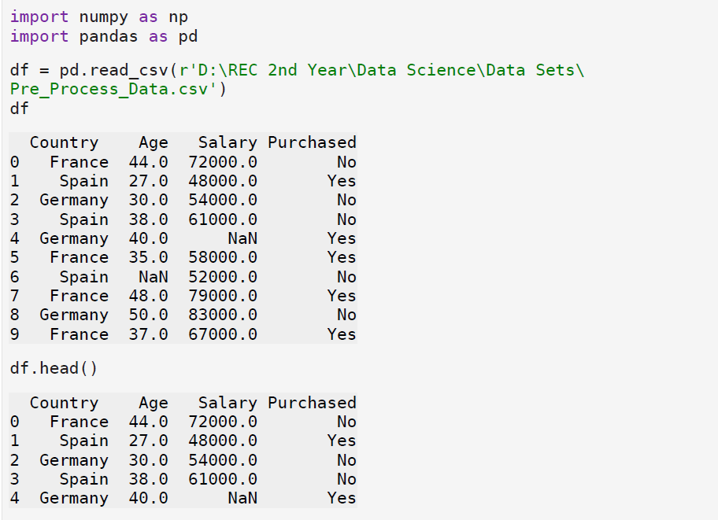

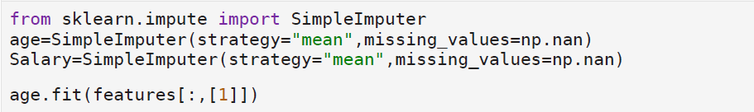

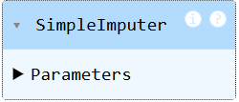

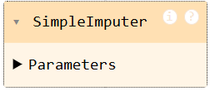

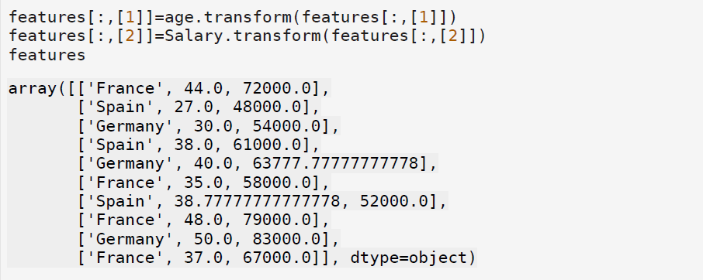
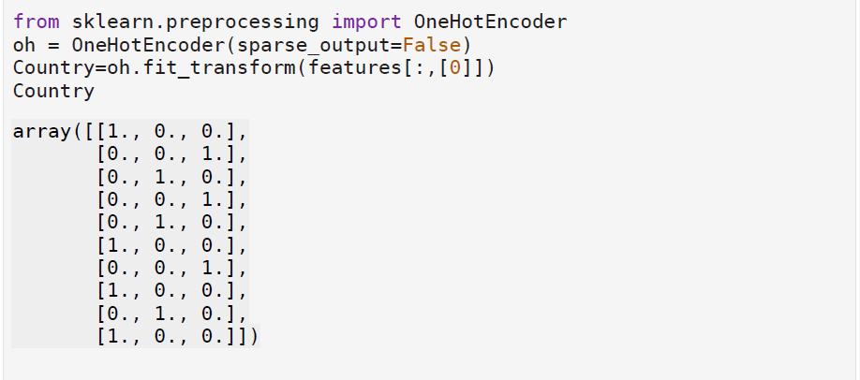

Result:
Thus python program to understand feature scaling was conducted successfully.

